Geography Programming Bootcamp

Welcome to our inaugural (and hopefully not the only!) Southampton Geography Programming Bootcamp. Over the next few days, you’ll receive an introduction into how you can use programming within geographical and spatial analysis to conduct a research project, from start to finish.

We hope the course gives you the confidence to pursue further learning in geospatial analysis and programming (see our recommended courses) whilst developing your skills and knowledge as a researcher.

As the first course of its kind in the Geography Department, please expect (and accept) some bumps and hurdles. Technology can be frustrating at the best of times, so please be patient if something isn’t going quite right and you need help - we’ll be with you as quickly as possible. If you find your neighbour is struggling, feel free to help them out - we’re all in this together!

This course has been created and taught by PhD students who themselves wanted to address a skills gap they felt currently exists in the teaching of Geography (not just at Southampton, but as a degree in general). We hope you learn something from the three days - and certainly will welcome any feedback at the end of the three days!

We hope you enjoy the course!

Jo, Kate, Chris, Josie and Rebecca

Course Timetable

The course is structured over three days. Day One focuses on Research and Data Management Techniques and provides an introduction into Programming within the ArcGIS/ArcPy environment; Day Two teaches you how to build iteration into your code to automate the ingestion and processing of data; Day Three teaches you the basics of using Jupyter Notebooks to execute geographical analysis using the Python programming language (exclusive of using ArcPy).

Day One

Time | Activity
9am – 9.30am | Introduction to Bootcamp
9.30am - 10.15am | Robot Race Programming Challenge
10.15am - 10.30am | Outline of the Course
Break
10.45am - 12.30pm | Getting started with our research project:  - Academic: research questions, goals and outputs, methodology design  - Practical: data storage & naming conventions  - Data cleaning and folder structuring
Lunch
1.30pm – 2pm | Creating a methodology within ArcGIS
2pm - 2.45pm | Introduction to ArcMap’s Programming Environment
Break
3pm - 5pm | Processing data in ArcMap and ArcPy

Day Two

Time | Activity
9am - 9:30am | A Functioning Egg Hunt
9:30am - 10:30am | Building Complex Workflows in ModelBuilder
Break
10:45am - 12.30pm | Using Iterators and Loops in ModelBuilder
Lunch
1.30pm - 3pm | Scripting and the IDLE Programming Environment
Break
3.15pm - 5pm | Listing logic and Loops in ArcPy scripts

Day Three

Time | Activity
9am -10am | From start to finish: Looping through 2.5 years of data
10am - 11am | The GIS Programming Ecosystem  and  Transitioning from ArcPy to pure Python and its Geospatial Libraries
11am - 12pm | An Introduction to Jupyter Notebooks
Lunch
1pm - 3pm | Data Analysis and Visualisation in Python: statistics, graphs and maps
Break
3.15pm -  4pm | Concluding our Research Project: Results and Future Research
4pm - 5pm | Wrap-up and Reflect

The Course

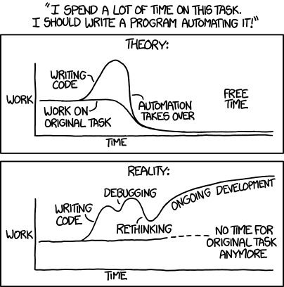
Day One: Using Programming Within ArcGIS

Brief

This morning, we are going to focus on the establishing the basic foundations for creating a successful research project, including the all important practice of data management and cleaning. This afternoon, we’ll get started with programming in ArcMap, learning how to use Esri’s inbuilt Python library, ArcPy, to process data in the ArcMap environment.

What you’ll do today:
- Learn how to get started with a research project, including defining research questions, setting outputs and designing a research plan
- Implement and clean data in GIS-readable formats, ready for processing
- Translate our research plan into appropriate GIS processing and analysis steps;
- Learn how you can use Python within the ArcGIS environment;
- Read in, edit and copy data in ArcMap with only a few lines of code and become familiar with ArcPy functions.

Formulate, Organised, Consistent, Useful, Simple

Every bootcamp needs its own acronym and here we’ve devised one that we hope will help keep your focus on the learnings, expectations and outputs you should get from the course:

Formulate: Any research project or programming script needs some sort of planning. You need to think about what your end outputs are and how you’ll get there. Breaking it down into small steps will help. Keeping a clear oversight

Organise: Keep your work organised. From file management and data storage, to making sure you save your work regularly and somewhere useful, being organised will save you time and effort keeping track of the progress you’ve made and data you’ve created.

Consistent: When it comes to your file and data management, be consistent and follow your organised structure. Make sure you always save in the right place! Then when it comes to naming your files, make sure to decide early on how you’ll write things up - capitals, no capitals, underscores or extended words.

Useful: And when you’re naming your data, files and folders, make sure it’s something useful! ArcGIS default names, export_1, export_2, etc… are not going to be helpful when using your data now or later on! Think descriptive.

Simple: But do try to keep your naming conventions simple - don’t overcomplicate them. Use acronyms sparingly, and follow well-known conventions e.g. population = pop.

Get yourself now into good habits and it will makes each project much easier to work with, for example, if you ever decide to run a programming bootcamp of you own!

Part One: Getting started with our research project

Research Project 101: Research Questions, Goals and Outputs

The first step to any research project is to decide what you’re going to research - if that’s already been decided for you, the next thing to do is determine the questions you want to ask and what outputs will help you answer them.







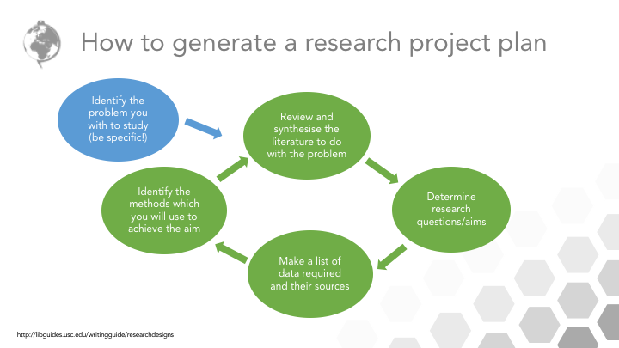
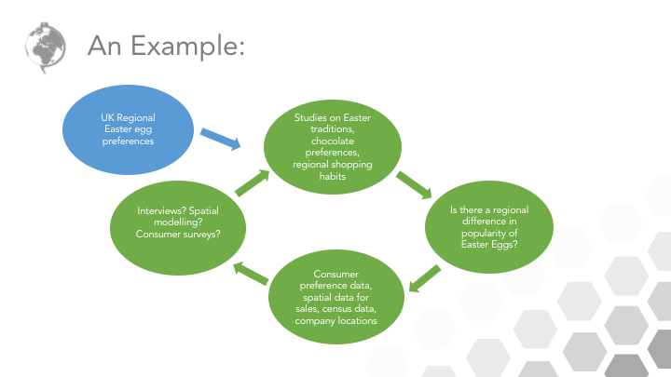


Data Management 101: Cleaning, Storing and Naming Conventions

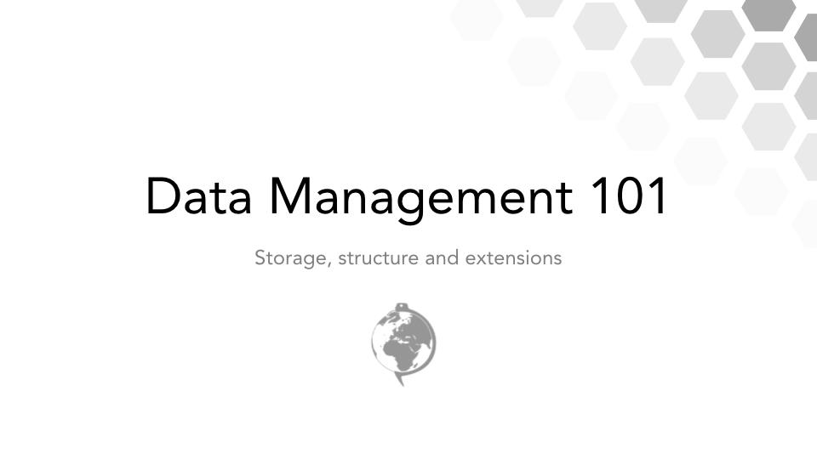

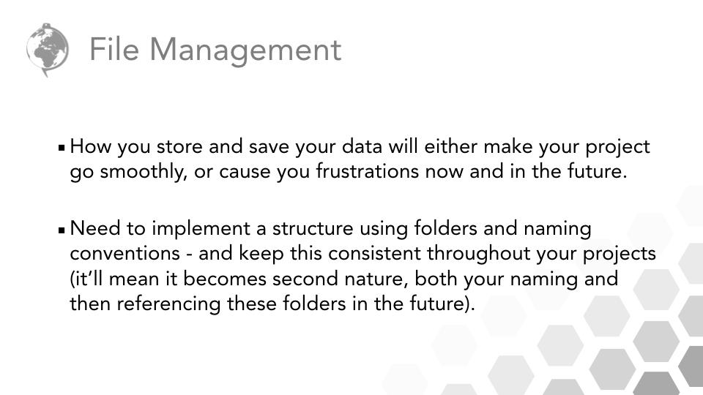

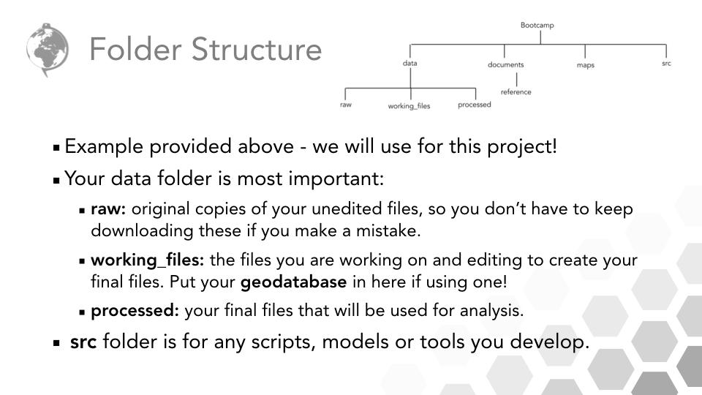

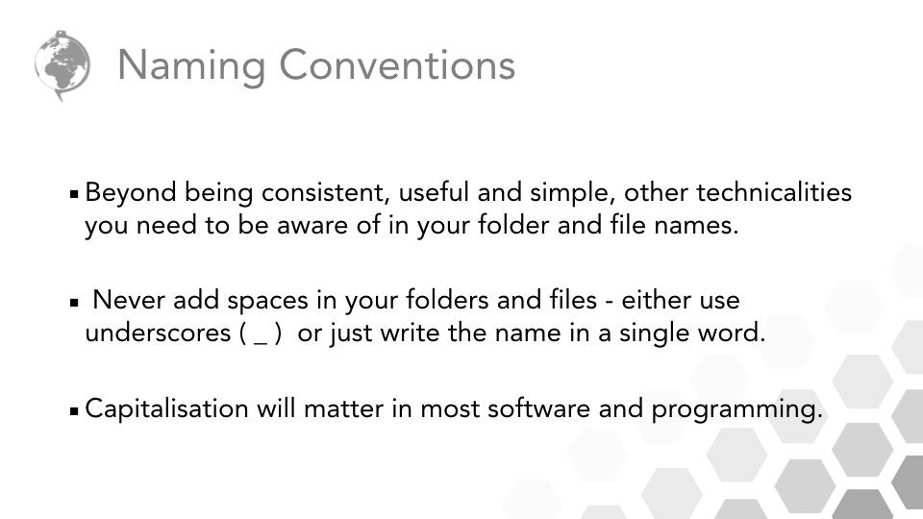

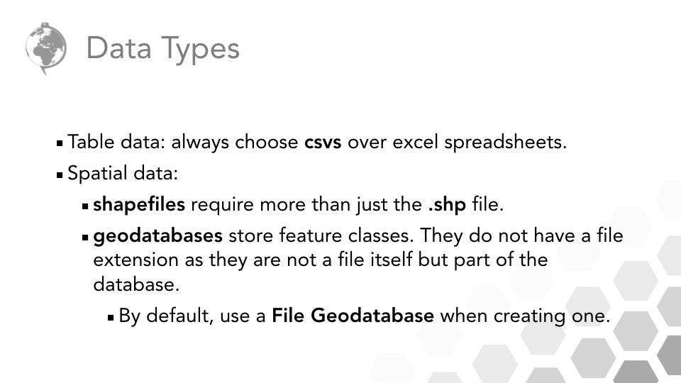

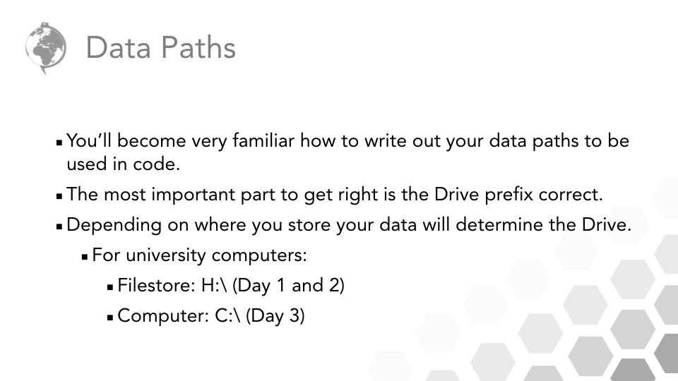

Get up and running with our research project: Public Safety Protection Orders (PSPOs) in Southampton

1. Download and open up the zipfile of data and documents (see the link provided on the board).

2. As you can see, we have a quite a few folders, files and also what looks like data in our unzipped folder. For now, we just want to look at the References to read document.

Briefly read through the links provided - as you read through the documents, try to answer the following questions.
Feel free to discuss the questions with your fellow Bootcampers.

- What is a Public Safety Protection Order?

- What sort of crime do the PSPOs tend to cover?

- When did the PSPOs come into force in Southampton?

- How many PSPOs are there in Southampton? Where are they located?

- Using your current knowledge about Southampton, how would you describe these areas? E.g. land use, population density?

- What controversial issues can you find about the introduction of PSPOs in Southampton?

- In which area of academia has the majority of research on PSPOs been conducted?

- Have you found any evidence that shows they work?

- Using what you’ve read so far, how do you think a geographer could help us understand whether PSPOs work?

Stay on this page for now - please put your green post-it up on your monitor to let us know you’ve finished answering the questions.
4. Jot down any notes during our discussion to help formulate your research ideas here!

Potential research ideas

5. Write out the final research questions so you know what we’ll be trying to answer this week.

Final Research Questions

Stay on this page for now.

Creating a research plan

6. Now we have our Research Questions decided, we need to think about how we can answer them - what outputs do we need to enable our analysis and how do we get them. This is all part of our research plan.

7. Let’s take a look again at our Research Questions - you should have them written out above.

Have the PSPOs been effective in reducing crime in Southampton?

RQ1. How has the crime rate changed in the LSOAs affected by the PSPOs?
RQ2. How has the crime rate changed in the LSOAs not affected by the PSPOs?
RQ3. Is there a significant difference in the crime rates?

7. If we break down these questions, we can identify key outputs that we want to result from our data processing.

8. First, our unit of analysis is crime rate. So our first consideration with our data is: how does a crime rate differ from a crime count?

9. As a result, if we are calculating a crime rate, what two types of data do we need? Where do you think we could get this data from?

Dataset One:

Source:

Dataset Two:

Source:
10. We then can identify the spatial resolution at which we will conduct our analysis, the Lower Super Output Area (LSOA), which will be our administrative boundary dataset.

- Where could we find this data?
- What are the other levels of administrative boundaries are there in the U.K?

11. We then want to study how crime rate has changed over time - which months do you think our analysis should cover?

12. Once we’ve processed our data, we can then get on with our analysis. We want to be able to compare how crime rate has changed over time and whether this change has been different for those LSOAs that intersect within the PSPOs compared to those that do not. We can use both maps and statistics to analyse any changes.

13. What extra GIS processing could we use to distinguish areas of high and low crime?

14. If we want to see if these high and low areas correspond to the PSPO areas visually, what extra piece of spatial data will we need?

15. We can also look at change over time by using the actual numbers and comparing crime rate between our two different groups, LSOAs that intersect within the PSPOs compared to those that do not. We’ll be looking at this more closely on Day Three but for now, think about:
- What sort of statistics could we extract from our two different groups to compare crime rate?
- What type of graphs could we use to look at change over time?

Getting our data ready for use - structuring and cleaning our folders and files

16. Now we have some idea of what we’re going to be doing today (i.e. we’ve formulated a plan!), we want to get organised. As you learnt earlier (and have through your GIS classes), being organised is a key aspect to a successful GIS project - it means you don’t lose data, you know where you data is and what your next steps are to process it.

17. To achieve this, we want to move our files into more useful folders and file structures. This can involve pre-empting the outputs you’re likely to get or want to make. Your folder structure in future projects will ultimately be up to you (there is a lot of guidance about best practice out there) but for this bootcamp, it is imperative that you follow our structure - or else our code will break, or you’ll have to rewrite it, creating extra work for yourself!

18. By getting into good practice early with folder structures and being consistent with folder and naming conventions, you’ll make each GIS project you work on easier and easier to navigate, organise and manage - and soon it will become just second nature. In turn, using useful and descriptive folder and file names will also help with being organised.

19. One of the benefits of being organised with your GIS work is that you make your projects “future-proof” i.e. if you come back to work on a project a few months later, you’ll have a general understanding of where you left off!

20. When it comes to organising your Bootcamp folder, you’ll need to add several layers of folders. The following diagram shows how we’d like to organise your folders and files:

Updated Files and Folder Structure: Start of Day One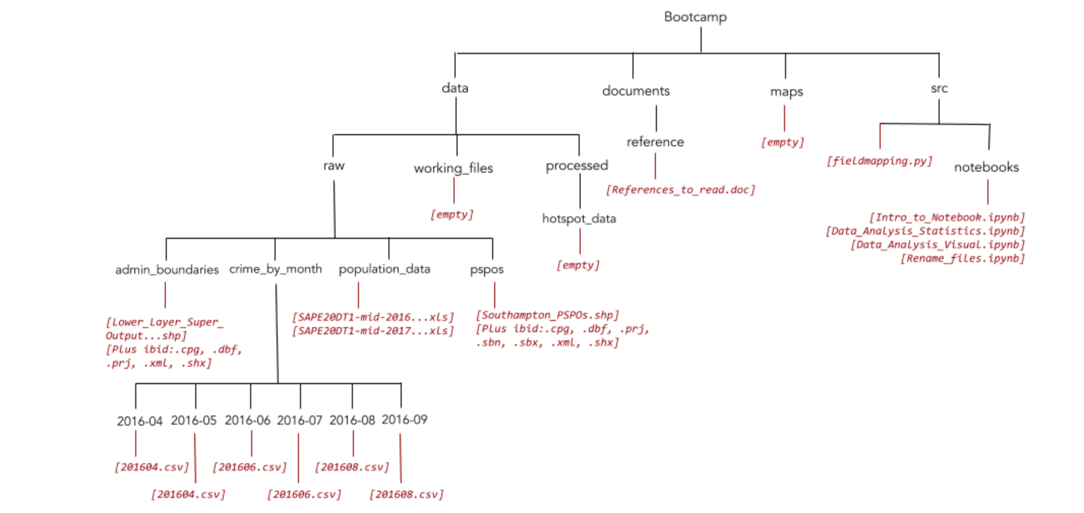

21. Now we have our files and data organised, we now need to see if we need to clean any of our data, ready for analysis.

22. By now in your GIS career, you should recognise different formats of spatial and non-spatial data - and also the requirements for their use. For example, with each shapefile, we should always have four data files present including:

- .shp: Shapes (mandatory)
- .shx:- Shape index (mandatory)
- .dbf: Attribute information (mandatory)
- .xml: General metadata (not mandatory for the shapefile to work but essential for telling you what the data is)
As well as preferably, at least information on
- .prj: Metadata on coordinate and projection system (optional)

In addition to:
- .cpg: Encoding information (optional)
- .sbn: Optimization file for spatial queries along with the .sbx
- .sbx: Optimization file for spatial queries along with the .sbn

23. We can check our England and Wales LSOA dataset (with the extremely long name) and our PSPO datasets to see if the required files are present. We’ll check the data itself more thoroughly when we add the data into ArcMap later.

24. The next type of data we’re dealing with is our table data. Table data is common format for raw data within GIS, often providing point data or attribute data that can be joined with some type of spatial data by a common field. In our case, we have both.

25. Let’s look at our crime data first. As you can see each csv is within its own folder, this is something we need to take a note of now - but not do anything about for the time being. Let’s have a look at one of the files, e.g. 201604.csv.
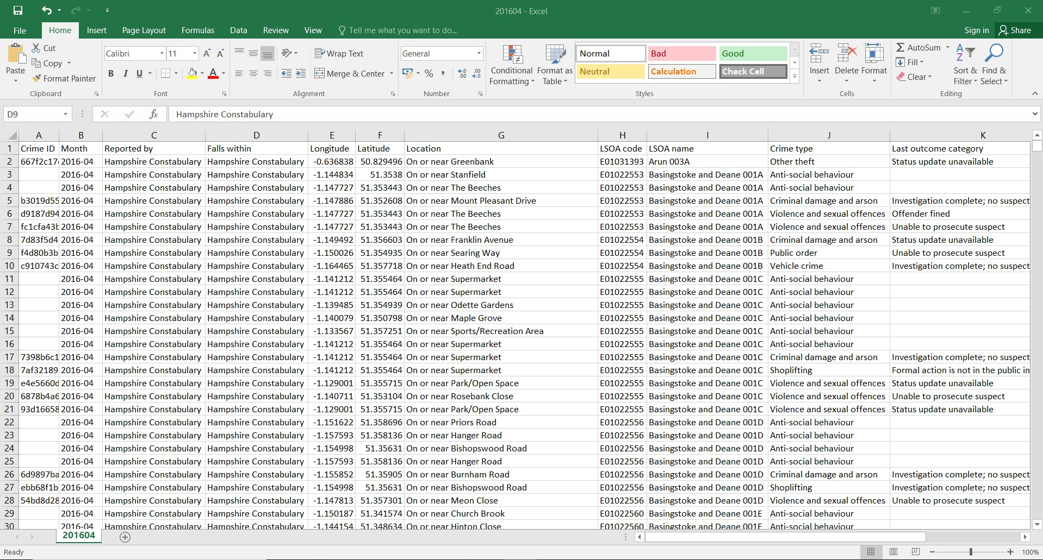
26. As we know the file is a csv, we only expect one table - and from the looks of it, that’s what we have. As it’s our crime data, what we are hoping for it two things: 1) spatial information to tell us where the crime happen and 2) information on the type of crime committed.

27. Luckily, we have both. Take a note of the names for the three columns we are likely to use and think about:
- What Coordinate Reference System do we usually associate with the spatial data columns provided?
- What crimes do you think are of most interest for us to analyse?

Spatial column A:

Spatial column B:

Likely CRS:

Types of crime column:

Likely crime types of interest:

28. With using tables in ArcMap, a table should be formatted in a specific way for it to be read in correctly:

For every table, the first row is automatically read in as the field names; rows are never read in as fields, they are only ever records.

29. As a result, whenever using table data in ArcGIS, whether as spatial data or as attribute data, you should always make sure your table is formatted accordingly. It is also generally easier to save a table as a csv rather than an Excel Spreadsheet to ensure that you are saving only one table - and it is the table that you are interested in! In the case of our crime data, the formatting is suitable and ready for processing.

30. For now, we can close down our crime csv and locate our population data, which also have really long names, in our folder structure.

31. Find the population data for 2016 and open it up. As you can see, this dataset is completely different (and more complex) than our crime csv. It’s an Excel spreadsheet with lots of sheets and even a front cover - as a result, we already know it is going to take some cleaning to be ready for use in ArcMap.

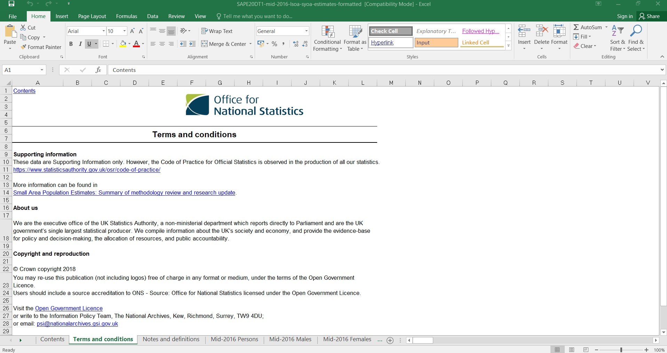

32. Each sheet in the spreadsheet contains a different set of data. What we’re interested in is looking at the population in mid-2016 for all persons. We can therefore navigate to this sheet.

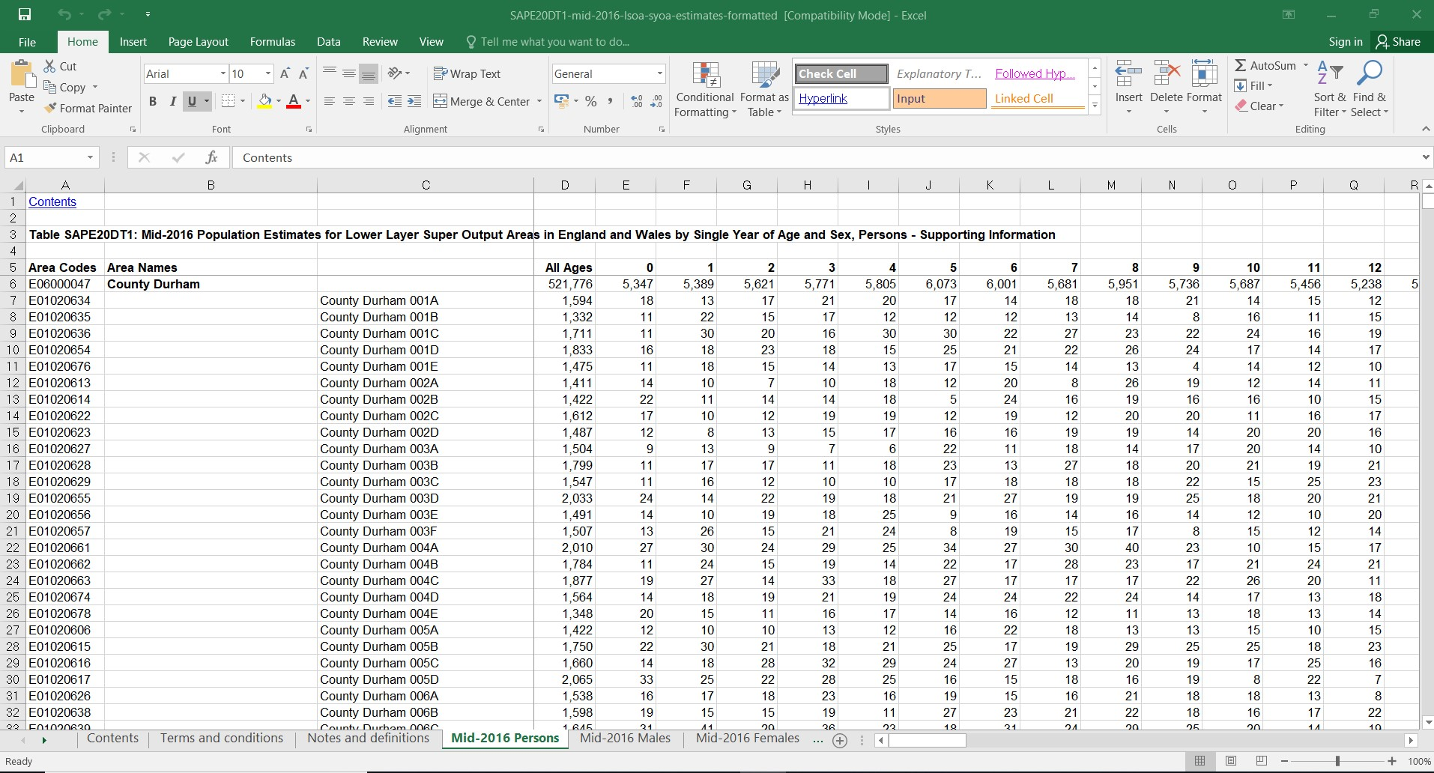

33. The sheet contains a lot of data - it has the population for every single LSOA and their respective Area in England and Wales, broken down by age. This is more data than we need and, furthermore, it isn’t formatted to the requirements we just outlined. But we don’t want to edit this original data - just in case we make a mistake, it’s there for us to come back to without having to re-download it.

34. Instead, we need to copy over all of the data from the all persons sheet into a new Excel spreadsheet. Once you’ve created a new spreadsheet and copied over the data, save it straight away, call it: lsoa_pop_2016, save it as a csv and save it within your new working_files folder.

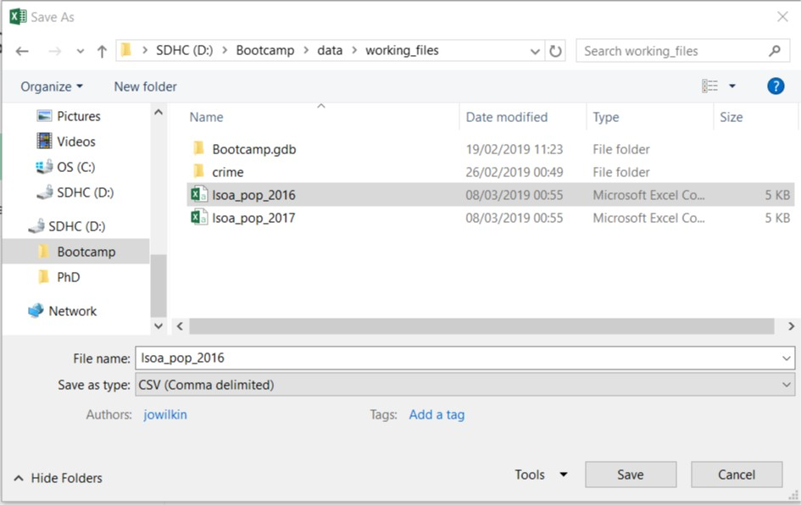

35. You’ll get a pop-up from Excel after you save the file. Click Yes to continue using csvs as a format - this will appear time and time again when converting from an Excel Spreadsheet to csv, just continue to click Yes.

36. Now we have the file saved, we can go ahead and start cleaning our data. As we only have two files to clean, we’re going to do this in Excel rather than try to edit the data in ArcMap. When you have large tables like this which require substantial formatting and not just data filtering, using Excel is far easier tool. Sometimes you just have to clean by hand - not everything works out better being automated!

37. The first thing we want to do is remove any unnecessary rows that will stop ArcMap reading our data correctly. As a result, we can remove rows 1-4 (if you copied everything over correctly). Make sure to leave the field names row (i.e. the row starting with Area Codes).

38. The next step is to rename some of our fields - as at least one is empty and several others have spaces in their name. It is best practice to never leave spaces in field names (or start the field name with a number) as both create bugs within ArcMap and Python. Rename the following two fields:

Column A: Area Codes → LSOA_CD
Column C: [BLANK] → LSOA_NM

We will be removing the rest over the next few steps so don’t worry about these.

39. The next step is to filter out only the data we are interested in - we are focusing our study in Southampton and at the LSOA level. There are multiple ways to do this, but we’re going to use the most straightforward.

40. Press Ctrl + F to open the Find box. Type in Southampton. This should take you to the start of the Southampton data. Click on the row that contains the Southampton in the Area Names column (Row Number: 25359).

41. After clicking on the row number so the whole row is highlighted, hold Ctrl and Shift together and press the Up button. You should see all of the data above, and including the Southampton Area row and the top Field Name row, selected.

42. Let go of the Ctrl button but keep holding the Shift button and press the Down arrow once. You should no longer have the Field Name row selected. Right-click anywhere on the table and select Delete.

43. The start of the Southampton LSOA data (Southampton 001A) should now be at the top of your table, underneath the Field Names row.

44. Scroll down to the end of the Southampton LSOA data - the next entry should be West Berkshire in the Area Names column at Row Number: 150. Select this row, hold Ctrl and Shift together and press the Down button. You should see all of the data below our Southampton LSO data selected.

45. Once again, let go of the Ctrl button but keep holding the Shift button and press the Down arrow once. You should no longer have the Field Names row selected. Right-click anywhere on the table and select Delete.

46. You should now have a total of 149 rows, inclusive of the Field Names row and 148 LSOAs. We can now go ahead and delete the Area Names column.

47. Save your csv - again click Yes to any formatting warnings.

48. Our next step is to change the age range that we will use for our population data. In our case, we only want to include those persons aged 10 and over. This division in the population is to include only those who are of an age of criminal responsibility i.e. can be charged with a crime.

49. To adjust our arrange, insert a new column before All Ages. Call it POP_2016. In the cell below, enter the following formula:

= SUM(O2:CQ2)

50. Press Return. You should now see the number 1,289 appear in the row.

51. Hover your cursor in the lower right hand corner of the cell - you should see the cursor change to a black arrow. When it does double-click. You should now see the cells below fill with numbers.

52. Select the entire column by click on the C (i.e. the grey area). Then right-click again in the same area and select Copy. Right-click again in the same area and select Paste Special. A box should appear. Choose to Paste Values (leave all the other options ) and click OK. Now if you click back in the original cell you wrote the formula in, we now have only a number not a formula.

53. We can now delete the remaining columns to the right of our POP_2016 column. We should only have three columns remain in the csv.

54. We have one last bit of formating to do. Right-click on our POP_2016 column and click Format Cells.

55. Choose the Number category and set our Decimal places to 1. Usually we wouldn’t add decimal places to population data (you can’t have half a person!) but we need this bit of data to be formatted with a decimal place rather than an integer (whole number). You’ll find out why tomorrow, but it’s important to add in this last step to prevent even more processing tomorrow. This is ultimately just something you end up learning - and we’re accounting for now to make things go smoother tomorrow! Press OK.

56. Save your cleaned csv and now repeat the same process for the 2017 data, naming the csv to lsoa_pop_2017 and the population column to POP_2017.

57. Once you’ve cleaned both of your csvs, we’re now ready to get started with our processing after lunch.

Warm-Up Exercise: Creating a GIS Processing plan

We already outlined a basic research plan with preferred outputs at the end of this morning’s session that we hope will answer our research questions. The thing is now we need to put it into practice - and understand how we can get to these output by processing our datasets within ArcMap.

To help you out, we’ve provided an empty flowchart of the processing steps you’re going to take as well as all the potential ArcMap options you could put in. We also have spare copies at the front if you think you’d like to update or re-do your flowchart as you carry out the methodology today.

You should be familiar with using flowcharting from your GIS courses. Most GIS-oriented flowcharts will consist of inputs, processes, and outputs (often split into intermediary and final) and you’ll find that different shapes and colours can be used to denote each one. We’ve done this already for you - but still think carefully what you end up putting in each box. There’s also space around the for adding in dataset names and paths as well as other bits of information you think you might need (e.g. column names you might think are useful for Joins and Relates).

Flowchart Components (NB: Not in order! That’s up to you!)

Essential
Display XY event | Select By Attribute: Southampton Location
Southampton LSOAs | Southampton LSOA with 2016 Population
Select By Attribute: Crime Type | PSPO-related Hampshire Crime Data (Month X) as Points
Add New Field | Southampton LSOA Crime Rate (for Month X)
2016 Mid-Year LSOA Population | Hampshire Crime Data (Month X) as Points
Spatial Join
Southampton LSOA Crime (for Month X)
Field Calculation | Additional
Join by Attribute | Field Name for Join
England and Wales LSOAs | Crime Types of Interest
Hampshire Crime Data (Month X) | Crime → Crime Rate Calculation
Southampton LSOA Crime (for Month X) [2]

INSERT A3 FLOWCHART HERE

Link to flowchart - it will be provided WITHOUT the text!

https://docs.google.com/drawings/d/12cfYsManYQUiVLer4yiE3pN_TFZR083TLFbXx4XxHgw/edit?usp=sharing

WITHOUT TEXT!

https://docs.google.com/drawings/d/1h7CzH-dPQtG2pv0D0BGxG8wj3Km3n7fZefakBO-5GLA/edit?usp=sharing

Part Two: Introduction to ArcMap’s Programming Environment

We’ve got our data cleaned and ready to process and we have an outline of our processing methodology - we now need to bring the two together and work our way towards our outputs. During this first session, we will provide you with a walkthrough of the ArcMap programming environment. We’ll demonstrate it live on the big screen as we talk through the text below but please also follow along on your own computer.

Whilst you wait...

Open up your folder browsing window and run a final check that your folder structure replicates that on page 20. Without the same structure, you’re likely going to run into difficulties running any of the code and even some of the processing within ArcGIS! It’s too early to introduce bugs into our work! If you’re still unsure of what each of our datasets are/contains, take ten minutes to go back through the datasets and familiarize yourself.

Programming bugs!

As Wikipedia kindly informs us, “a software bug is an error, flaw, failure or fault in a computer program or system that causes it to produce an incorrect or unexpected result, or to behave in unintended ways.” As you progress with programming, you’ll see bugs happen all the time with your code - and usually it’s because we’ve made an error, not the computer.

Common bugs you’re likely to have to squash this week are:

- Typos, typos, typos. Writing code requires a perfect level of precision. Rushing can lead to making small mistakes - a missing ‘s’ here or an extra ‘.’ somewhere can easily break your code.
- Missing code-specific syntax requirements. Each programming language uses symbols, such as . ( ) ! * & : , in many different ways. You have to learn what and why to use them.
- Indentations mean something. In Python and other languages, the use of indentations provide structure, order and logic to our code. It’s not just there to make it look pretty. Either not using indentations or using too many can change what your code does. You need to hit the tab button to add in an indentation (and don’t use the spacebar!).
- Incorrect paths or filenames. But I swear I put it there…. Well, you didn’t. Or else the computer would find it. ‘No such file or directory’ is likely to be an error you’ll see a lot. But it’s always easy to fix, if you keep your files and folders well managed and organised.

We’ll be coming across these bugs throughout the week - so don’t worry when you find your first one. It’s something we all have to just accept it is part of the work process! Also if you don’t understand some of the bugs as explained, don’t worry - you will soon!

Initial Set-Up

1. Open ArcMap from the Start Menu / Toolbar.

2. Create a new map, and for now leave the default Geodatabase as the one already entered.

3. To get ourselves set up, ready to work, let’s create a folder connection to our folder of data (if you don’t have one set up already from exploring the data!):

H:\Bootcamp\

If you’re unsure about how to make a folder connection, let us know by putting your red post-it note on your computer. If it keeps falling off, just put your hand up.
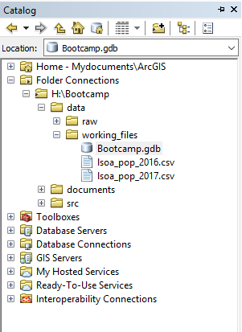
4. Now we have a connection, let’s create a new default geodatabase to make sure none of our data gets lost during processing. In the Catalog window, navigate to your working_files folder, right-click, hover over New and then click on File Geodatabase. Call the Geodatabase, Bootcamp.gdb. Press return, then right-click on your new Geodatabase and select the option to Make Default Geodatabase.
Creating and using your own Default GDB is a good practice to get into early on. There will be many times in your GIS career where your file management practices might not be the greatest (hey, we all do it!) but if you at least maintain a GDB for each project you’re working on, you give yourself a good chance to track and find your data!

5. Let’s go ahead and save our .mxd document. If we save it now, we can get the path and naming convention sorted and then just use the Ctrl + S shortcut during our processing to keep our mxd up-to-date. Save the .mxd in the main Bootcamp folder as Bootcamp_Processing.

Next, we’re going to talk a little bit about the ArcMap main window, and the different windows we can add or remove from our display.

Exploring the ArcMap environment

Through your previous GIS tutorials, you should be familiar with using the ArcCatalog window (on the right) and the Table of Contents window (left). You’ve probably also come across the Search and Toolbox windows as well.

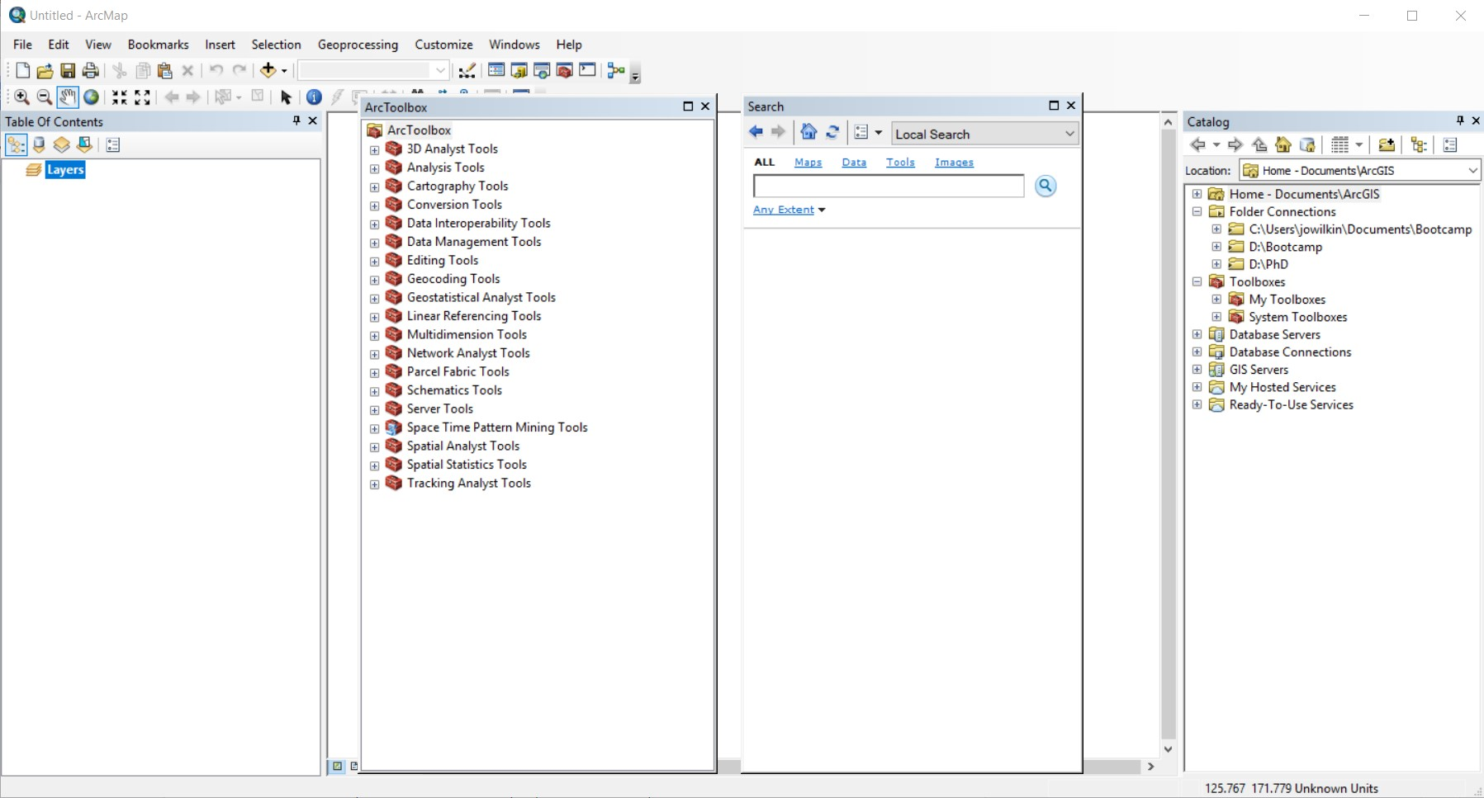

There are also several other windows that we can open up to use for specific functions.
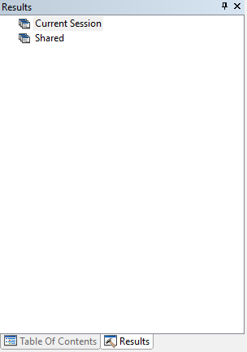
4. First, let’s look at the (1) Results window. You can either open it from the Geoprocessing tab or by clicking on the shortcut icon, , if it is displayed on your screen. It usually pops up on the left-hand side of the screen, next to the Table of Contents. The window will be empty as we haven’t completed any processing as yet. It records every processing tool you use, including the tool used, inputs and outputs, environments used and any messages (useful as this is where ArcMap tells you what’s gone wrong if something has gone wrong). The results window will also tell you any processing that didn’t run, or if you’ve saved your work as part of a .mxd, it’ll provide a history of sessions that detail processing from previous times you’ve worked on that .mxd project. The results window is extremely useful, and as we go through this tutorial you’ll find out why.

5. Next, we’ll open the (2) Python console. Again, you can open it from the Geoprocessing tab or through its own shortcut icon . The console will also be empty, apart from the Command Line indicator, known as the prompt and symbolised as >>> . Code can be entered directly at the prompt and run by pressing return.

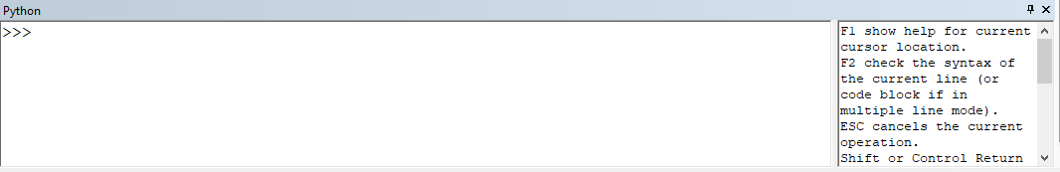

6. Have a go at conducting some basics maths, and enter after the prompt, 3 + 3, press return and see what happens!

The Python language comes with basic maths functionality, hence why your code can run. You can subtract [-], divide [/], multiply [*], exponentiate [**] (and a few other functions) all from the Python console.

Using Python within ArcMap / ArcGIS

The Python Console can be used to enter simple Python code as well as longer and more complex scripts. It’s a really useful tool as that helps you to learn to code in ArcPy (referred to in Python as arcpy), Esri’s proprietary Python library that allows you to access the (geoprocessing) tools and toolbox used in ArcMap. The console has a really friendly User Interface that helps you code by providing a lot of autofill functions e.g. suggesting the datasets you might want to use with a specific process as well as telling you what inputs, outputs and parameters the tool is expecting. The main issue with the console is that it’s not very user friendly when you start to write code longer than one or two lines. As you can already see, it’s pretty small and resizing it is fiddly! Furthermore, as you’ll see when using code-focused text editors, it is limited in its ability to actively help you debug your code as you write it (e.g. highlighting the absence of brackets, or the fact there’s too many!) and it’s difficult to edit your code and save it for future use. It works out much better to export and write your code in a separate editor and then copy or import your code to run it in the ArcPy console.
In addition to the Python Console, there are two other ways to interact with Python and ArcPy.

The first is to run ArcPy from a standalone script - we’ll cover this in the afternoon session with a how-to in using the IDLE programming environment.

The second is to create a script that is then added as an ArcMap tool. We won’t be covering this approach, but you can find out more through Esri’s Help documentation (e.g.http://desktop.arcgis.com/en/arcmap/10.3/analyze/creating-tools/a-quick-tour-of-creating-script-tools.htm ).

However you use ArcPy, there are two important things to note.

Firstly, licenses. ArcPy is Esri’s own Python library and requires ArcGIS to be installed on the desktop that you’re running the code on to use. If you want to use ArcPy, whether within ArcMap and the Python Console or as a standalone script, you’ll need to have ArcGIS installed and licensed. For those Mac users or if you’re unable to have a license for ArcGIS (e.g. when you leave University or a company who doesn’t use ArcGIS) this is an issue.

Secondly, versions. ArcPy for ArcMap (integrated within ArcGIS) utilises an older version of Python (2.7). ArcGIS Desktop Pro (the new, snazzy, more expensive fully integrated ArcGIS) is built to use the newer version, 3. Furthermore, on Day Three with our Anaconda installation, we’ll be downloading Python 3. This is because many of the geospatial libraries we’ll be using are starting to no longer support Python 2.7 and general support for Python 2.7 will stop next year. Preferably, it’d be great to work solely in Python 3 but with ArcMap, this isn’t quite possible! The main challenges are actually recognising which version you’re using on your computer (we’ll show you how to check this) and remembering some of the subtler changes between the two (the most common you’ll come across is to do with the print statement/function and parentheses). But don’t worry, we’ll try to cover as much of these as possible - and there is always documentation out there to help you - it’s just an issue you should be aware of as it could become a source of bugs in your code.

7. We want to keep the Python Console available for our processing today, so if it’s not already locked in to your window, drag the window to the bottom slot. Try and set up the rest of your ArcMap display as below, pinning into place the Results, Search and Toolbox windows.

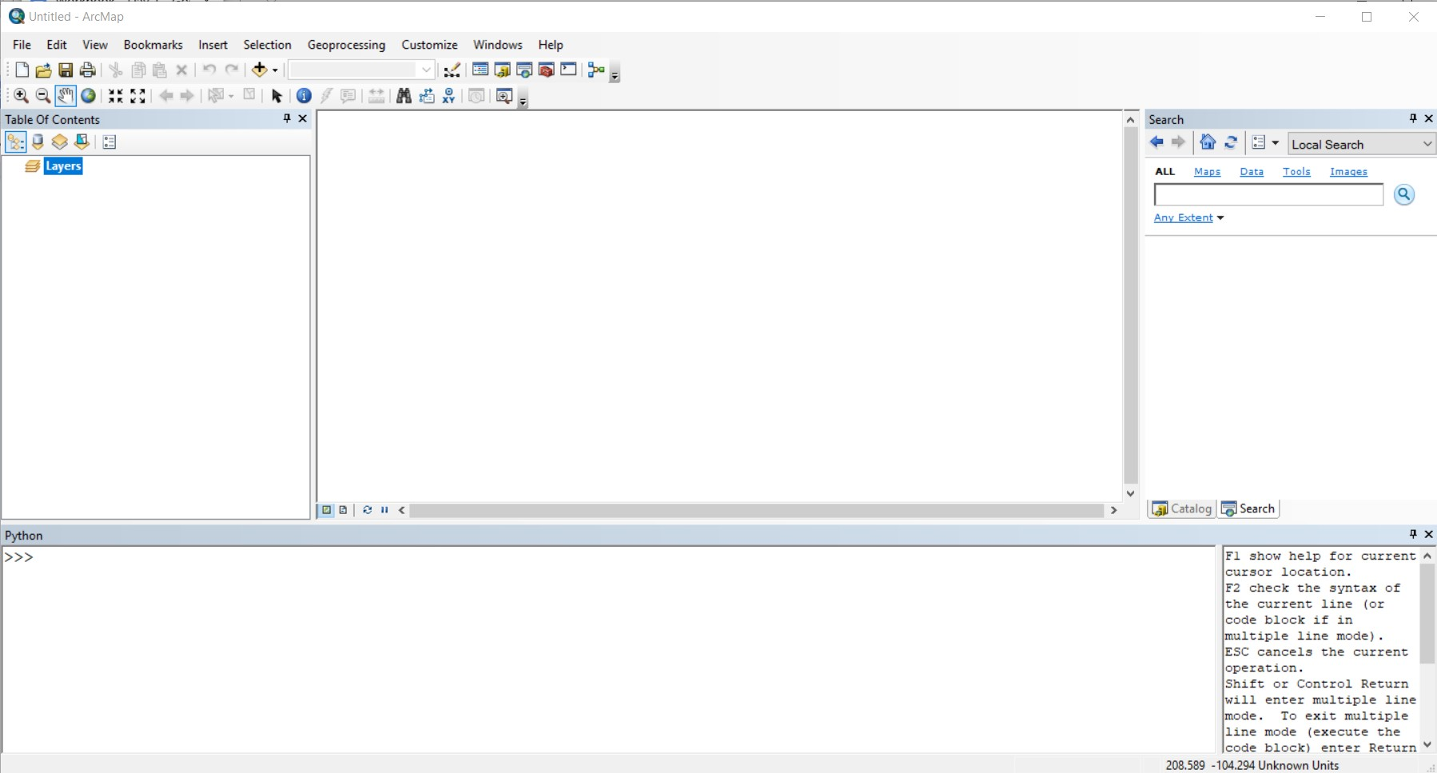
8. The final “window” we’ll open, (3) ModelBuilder, is not exactly a window, but can be accessed the same way as the other windows through the Geoprocessing tab or its own toolbar button, .

ModelBuilder is a tool built for ArcMap that allows you to create models to run the processing of geospatial data. The models take the format of something we’ve already used today - flowcharts. Just as our flowchart we were using earlier, ModelBuilder displays our Inputs (i.e. our Datasets), Processes (Tools) and Outputs (Intermediary/Final) using different shapes and colours. There are lots of other functionality with ModelBuilder which we’ll get around to this afternoon. For now, you can see the first step of our methodology presented as a model within ModelBuilder in the screenshot below with the three main components: an input, process and output. We’ll be creating this model later, so don’t try to replicate this just yet.

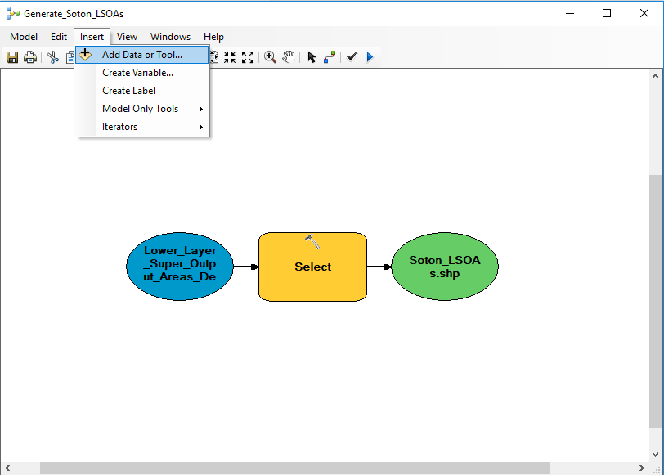

9. Close the ModelBuilder window.

Now we’ve had a brief introduction to the windows we’re going to use today, we can begin our processing!

Part Three: Processing data in ArcMap and ArcPy

Our processing takes the form of three steps, as shown in our Flowchart from earlier this morning. We’ll be using different approaches in each Stage to learn how to code these Stages and by the end of the day, we’ll have a final script that we could use to run on the raw (cleaned!) data, over and over again. Let’s get started.

Step One: Extracting Southampton Only LSOAs (Manual)

The first step of our methodology is to extract only Southampton LSOAs from the England and Wales LSOA shapefile to ensure we’re only focusing on our Area of Interest.

To extract these LSOAs, we need to select them and export them as their own dataset. We could use multiple approaches to selecting our LSOAs, including manually clicking each individual LSOA, drawing a polygon to or even using another shapefile. But we want our selection to be able to be automated - and not have other dependencies, such as an external shapefile. We will be using the Select tool, which allows us to write a Query to select our LSOAs.

Don’t worry - we’re not going to code this up straight away. We’re going to use an iterative* process going from using the normal ArcMap GUI* to get us to the final script.
*Make sure you understand these terms - they are important terms when programming.

Manually, clicking through.
↓
Use the Tool record in the Results window to export the process as a script to the Python Console
↓
Break down the script to understand how to write the tool in Python code

1. Drag the Lower_Layer_Super_Output_Areas_December_2011_Full_Clipped__Boundaries_in_England_and_Wales.shp from Catalog window into the ArcMap display / Table of Contents. (It’s in H:\Bootcamp\data\raw\admin_boundaries).
2. Navigate to Southampton. Use the Select arrow to select one of the Southampton LSOAs - it doesn’t matter which one, just try to make sure it’s definitely in Southampton.

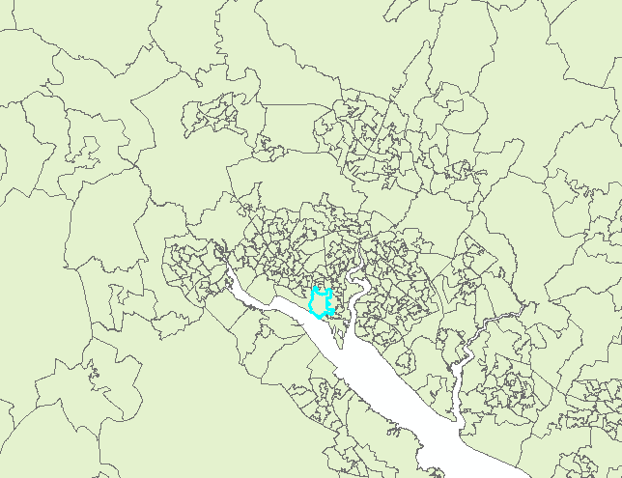

3. Open up the Attribute Table of the LSOA shapefile. Use the 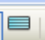 button at the bottom of the Attribute Table to show only the selected LSOA.

If you’ve never seen this before, make sure to note this useful feature - there’s also another button at the top of the Attribute Table that allows you to reverse your selection.

4. Have a look at the Fields and respective attributes of our LSOA. Which Fields do you think help tell us that this LSOA is Southampton?

Usually we try and always use codes (where possible) when dealing with geospatial data, particularly when using Administrative Boundaries. Codes are usually one of the most unique fields within a shapefile and it is often easier to spot errors or typos than in fields that contain words or, even worse, spaces between words! The latter are very easy to make mistakes with, particularly when editing a dataset.

5. In this case, we don’t have an encyclopaedic knowledge of which LSOA codes correspond to Southampton. We’d need to know the range of the codes and use this range within the Query that we’re going to use to select our LSOAs. Instead, we could go for a more obvious solution - if we look at our selected LSOA, we can see immediately that the LSOA has ‘Southampton’ in its LSOA Name field. This will be the basis for our query.

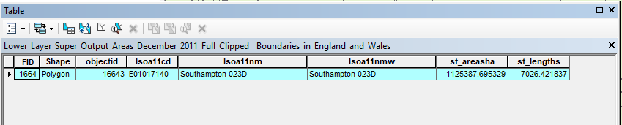
For now, unselect your current LSOA - you can either go to the Selection menu or use the deselect shortcut button - to ensure our we generate a new selection in our next step.

6. Let’s open up the Select tool. To find it, we can use the Search window. Open the Search window and type in Select - you’ll see a range of tools pop up and the Select toolbox. We’ll click on the Select(Analysis) tool, but take note of the path of the tool in the green font. Write it down in the box to refer to in future.
Select Tool path

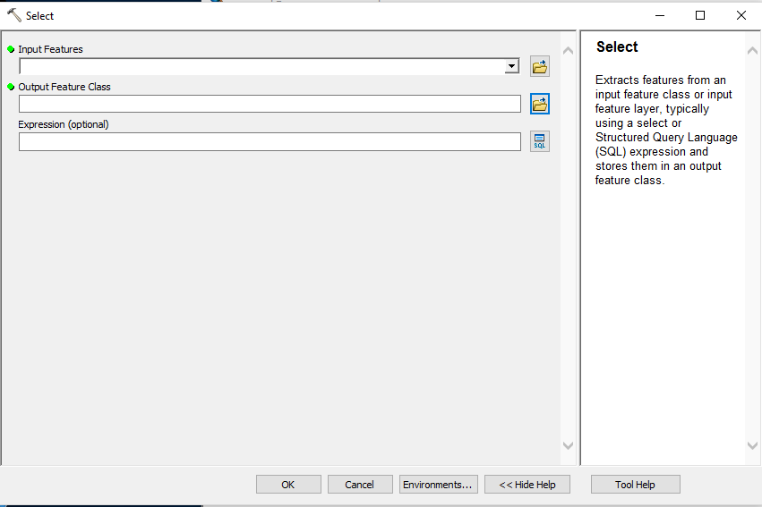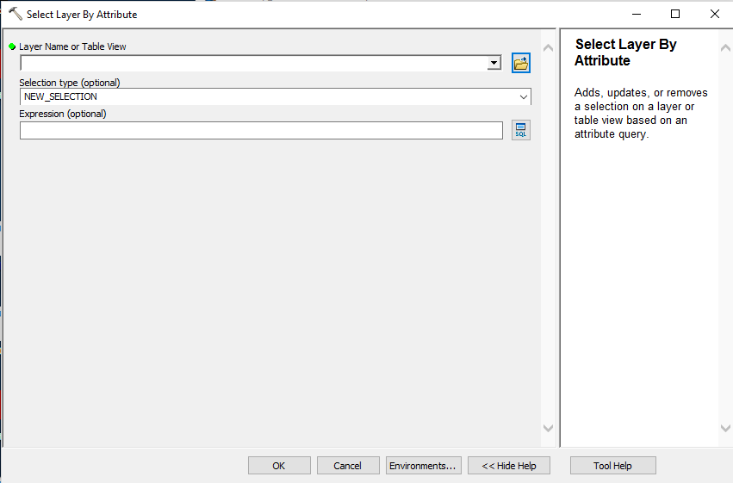
Select tool (use this one!) Select by Layer tool (not this!)

Note use the Select (Analysis) tool, not the Select Layer by Attribute tool. The latter does not export the selected files automatically to a new dataset - and is similar to using the Select By Attribute options within the Attribute table or the Selection tab. It is useful for when you want to build up multiple selections or not necessarily want to create a new dataset from your selection.

7. The format of the Select tool should look familiar and consists of three components: the input dataset, the output dataset and the (optional) expression used to select the appropriate data. The input dataset will be the England and Wales LSOA shapefile (selected from the drop-down arrow), whilst the output dataset will need to be set by yourself. You need to enter the appropriate path and name for the dataset:

H:\Bootcamp\data\working_files\Southampton_LSOAs.shp

8. Now we have our output feature set, we need to enter our Query and will use the SQL Query builder to so do, accessed by the button. As we know, we’re using the LSOA Name field so we can double-click on the field, lsoa11nm, to enter it into the Query box. By double-clicking, we’re making sure our field is formatted correctly. As you can see, the field name is enveloped by “” - this is a form of syntax used by SQL to denote a field name - it’s something you need to be aware of that is specific to SQL.

Select By Attribute syntax & Wildcards!

The Select By Attribute tool uses a programming language called Structured Query Language, otherwise known as SQL. SQL is primarily used to query data and databases based on using conditional statements.

Conditional statements are primarily used to test whether a rule or expression is true, and IF it is, to carry out an action. IF it is not THEN, carry out another action or do nothing. There is also an option to set further IF tests by using an ELSE statement. This level of complex SQL tests are not covered in the course but are certainly covered by most Introduction to Programming courses e.g. CodeAcademy.

In GIS, the most likely SQL test you’ll come across is the one used by the Select By Attribute tool:

SELECT * FROM Layer_of_Interest WHERE...

Here, we are SELECTing *, i.e. every row or column, FROM our layer of interest (a feature class, table or shapefile) WHERE the test or rule used is found to be true.

It is important that the test entered follows the expected syntax used by SQL. As you can already see from double-clicking our field, any fields within the query builder should be defined by “”. In addition, when querying a field that has text-based values within it, such as a code or name, single ‘’ are required either side of the value. These single ‘’ mark that text as a string of data. In comparison, for numerical values, such as the length of a shape or even potential additional attributes such as the population size of an LSOA, do not need to use ‘’. We’ll be coming across these two data types, strings and numerical values, again so don’t worry if you’re not exactly confident in understanding the difference.

Another thing to note is that SQL commands are also always in CAPITALS, as illustrated above.

Building the rest of the query then relies on how exactly you are trying to evaluate the data. There are different operators as well as things called Booleans that we can use to create our test. We’ll go through these a little later on in the course, but if you’re interested the following link can get you started: http://desktop.arcgis.com/en/arcmap/10.3/map/working-with-layers/building-a-query-expression.htm)

In the end what we want to get across is that we need to be careful of the syntax used by the query builder, and ensure we use the appropriate symbols and words required. The syntax of any programming language is important - and to make things difficult, there are differences between the languages you may end up learning but it’s just a matter of experience to build up the knowledge to know what to use when.

For example, here we have a really simple query to finish - or relatively! We’re interested in all LSOAs which have Southampton in the name. But as we saw with our selected attribute, our names are formatted as Southampton 000A - which means we can’t use a simple query such as:
“lsoa11nm” = ‘Southampton’

It won’t return any values as there is no LSOA with the name exactly as Southampton. But what we can use is something called a wildcard. You may have come across wildcards when searching for literature or just when using a search engine. Wildcards allow you to substitute one or multiple characters for a symbol, in order for you to search for something similar if you’re not sure what you’re looking for or, in our case, you’re looking for a group of items with a similar attribute.

For ArcGIS, there are specific symbols you use for specific data types.

For any file-based data, such as a shapefile or CSV, the use of a _ substitutes one character.

For example, using the query within the Select By Attribute tool:

“lsoa11cd” LIKE ‘E0100000_’

Will return all of the LSOAs for the City of London and fourl from Barking and Dagenham:

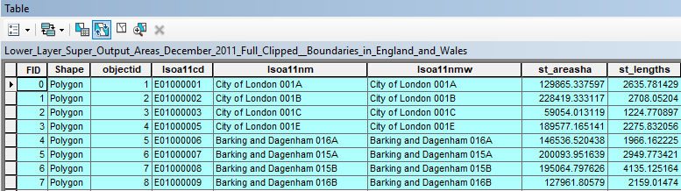

Alternatively, for file-based data, we can also use the % sign to substitute for multiple characters (in fact an infinite number of characters or even none at all!). You could substitute the _ for an % in the code above, and will return the same result. If you remove a second 0 from the code, and then add in the %, you’ll end up with LSOAs from the City of London and up to Barking and Dagenham 023E.

“lsoa11cd” LIKE ‘E010000%’

For any feature classes that are within a geodatabase, you’ll need to use a ? instead of a _ for a single character and a * instead of a % for multiple characters.

One more thing you should notice is that we’ve also changed the mathematical operator from = to the statement LIKE. This is because an equals sign will interpret any character within the string as part of the string and not as a wild card. You need to use LIKE to ensure the wildcard is interpreted.

10. So now we know a little bit more about writing an SQL query and we may just have a solution to our query. As we know, we want to extract all LSOAs which have a name like Southampton 000A. So let’s write in our query and get our LSOAs selected!

“lsoa11nm” ‘ ’

11. Run the tool - you should now have your Southampton LSOAs selected and exported into a new shapefile within your working_files folder.
12. Load the Southampton LSOA shapefile into ArcMap if it is not automatically loaded. Untick the England and Wales LSOA shapefile in the Table of Contents. Check that your LSOAs look similar to this (it should be a familiar shape of Southampton):

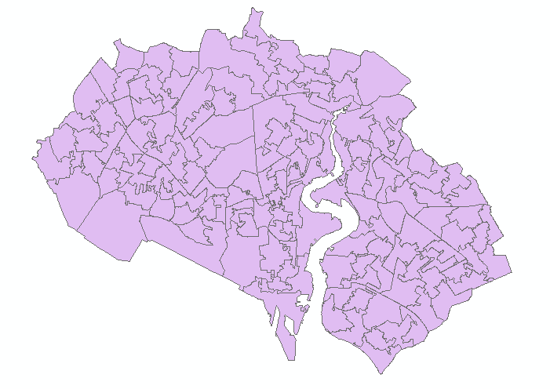

13. Open up the Southampton LSOA Attribute Table and check that you have 148 LSOAs. If not, and you’re not sure where you’ve gone wrong, please let a demonstrator know.

14. Close the Attribute Table and remove the Southampton LSOA from the Table of Contents. Next, using the Catalog window, find the saved shapefile and delete it. Yes, that’s right, delete the file you just created!

Step One: Extracting Southampton Only LSOAs (Program)

15. We now know how we will export our Southampton LSOAs, what query we’re going to use, and what our output should look like. But we want to know how to do this without using the GUI interface - and preferably how to use ArcPy to do this processing for us.

16. As stated before, the Results window records every processing step that you’ve completed during your session on ArcMap. If you don’t have the window open as yet, open it up and drag it to the left hand side into the same space as the Table of Contents. If you’ve managed to drag it correctly, you should now be able to tab between the Results window and the Table of Contents:

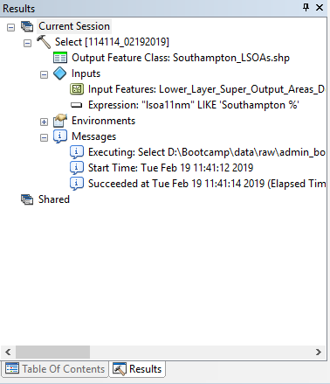

17. Open up our current session. It should have a plus next to it to expand, if it’s not expanded already! You should see the Select tool at the top of the session - expand it so we can get a closer look:

As you can see, the Results details lots of different aspects of our Processing, including the Output, and Inputs (the Input feature/dataset and Expressions). You can also see any messages ArcMap thinks you might want to know - including when the tool was executed, start time and when it finished. If your tool is not successful, it will also provide you with suggested Error information.

18. What’s really great about ArcMap and programming is that we can use our Select processing to actually generate Python code or even a Model. If you right click on our Select tool in the Results window, you should get several options, include Copy as Python Snippet.

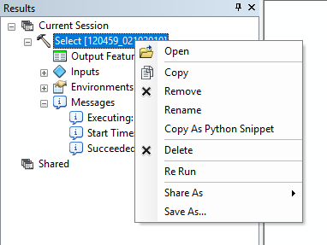

We’ll be using this option later, but for now click directly on the Select tool, hold and drag down into the (already open) Python console. The following code should pop up in the box:

>>>arcpy.Select_analysis(r'H:\Bootcamp\data\raw\admin_boundaries\Lower_Layer_Super_Output_Areas_December_2011_Full_Clipped__Boundaries_in_England_and_Wales.shp', r'H:\Bootcamp\data\working_files\Southampton_LSOAs.shp', "\"lsoa11nm\" LIKE 'Southampton %'")

19. By just reading the code, you should be able to recognise the majority of its components - even if you’re not entirely sure what they do or why they’re in a specific order or format. Fortunately for us, ArcPy provides us with an easy in to understanding some of the basic principles of code - and maintains a relatively simple format for us to use lots of different geoprocessing tools without having to learn too much. So let’s take a look at a breakdown of the code:

Function:  arcpy.Select_analysis() | The Select tool written as an ArcPy function. A function runs some code on a set of inputs, provided in the round brackets ( ) following the function’s name.
Input 1: r'H:\Bootcamp\RAW\Lower_Layer_Super_Output_Areas_December_2011_Full_Clipped__Boundaries_in_England_and_Wales.shp’ | The Input dataset on which we’ll be doing the Select Analysis - in our case the LSOA shapefile for England and Wales. Here the dataset path is used. Denoted as a raw (r) string (we’ll explain this later).
Input 2:  r'H:\Bootcamp\working_files\Southampton_LSOAs.shp' | The path and name that we want to set for our Output dataset, denoted as a string.
Input 3:  "\"lsoa11nm\" LIKE 'Southampton %'" | The SQL query written for the selection, denoted as a string.

20. The first part of the code to consider is how we access our geoprocessing tool, Select, in ArcPy. Here we access the tool as something known within programming as a function.

ArcPy, Functions and Libraries

We’re now starting to head into some key programming terminology and so it’s a good chance to take a slight pause and take stock on just what exactly all these things mean.

Starting with ArcPy (or arcpy when used in Python code). As stated earlier, ArcPy is Esri’s own Python library. What this means is that someone (or rather a team of people!) at Esri have converted the geoprocessing and spatial analysis tools you’ve become familiar with whilst using ArcMap into Python functions..

A function appears as a short command (such as our Select_analysis() function above) but, in fact, behind the scenes, there can be complex code written in either Python (or potentially another programming language) that runs when the function is called. A function usually takes a set of inputs (also called arguments or parameters) and runs some code on these inputs to generate an output. The inputs are provided in round brackets ( ) after the function’s name and you always have to type out the round brackets, even if the function doesn’t require any inputs.

Functions allow you to reuse code so that you don’t have to write the same tens or hundreds of lines of code every time you want to do something, such as select data for your analysis.

Once you develop a set of functions for a particular purpose, you can collect them into a “library” (also called packages or modules). Libraries are simply sets of functions and code that you can reuse between your own projects or share with others.

ArcPy is just one of many libraries that have been written by other Python users to improve and extend the usability of the Python language. In fact, many of the libraries we’ll be using on Day Three are still pretty new as geospatial analysis within Python only has become increasingly popular within wider data analysis in the last ten years or so.

The libraries and the functions you find within them are usually written to fulfil a certain purpose; for example, the rasterio library enables the reading, processing and analysis of raster datasets, whilst the math library contains lots of mathematical functions, such as sqrt() which returns the square root of your number. In our case, with ArcPy, there are extensive amount of functions that cover our geoprocessing and spatial analysis tools.

We’ll be spending some time Day Three getting more familiar with some other spatial-related Python libraries and some functions that replicate many of ArcMap’s tools. This means you’ll be able to conduct lots of the processing and spatial analysis we do today – but all without the need for an Esri licence! Finding them - particularly when you’re looking for a specific analysis - however does require searching the internet for documentation and reading whether the library has a function (or functions) you can use, and this can sometimes feel a little intimidating when you’re used to using software that has most things built in. In some cases, there may not be a function that does what you want to do – and that’s where writing a function yourself comes in, but we’ll discuss this more Day Three.

Another thing to note is that Python does however has some functions already built-in and a lot of them are very useful. For in-built Python functions, you don’t need to precede the function with any library name (as we do with arcpy.function( ) or math.sqrt( )).

For all functions we do need to use the parenthesis in order to provide our inputs to the function when it is called. These arguments are pre-set and pre-defined by the function, from how many arguments you need to include, whether they are optional or not, the order in which they should appear within the parenthesis (or if they need to be in order, another wonderful addition to programming complexities we will cover briefly in the course!) and what type of data or variable the argument is expecting (e.g. a string, number, path etc.).

21. In ArcPy, functions are relatively easy to understand - as they’re the geoprocessing tools you’ve been using during your GIS career to date. You’re used to opening a tool and entering in input and output files, as well as other parameters, such as SQL queries or distances for buffers, for example. You’re simply replicating this process but using code instead to (a) open the tool, (b) enter the parameters and (c) run the tool. You just need to adapt to a different syntax. So, firstly, to be able to call a function, programming-speak for use, we need to know where to find it i.e. which Python library it belongs to. And as we’re using a function from ArcPy, we know that’s where it’ll be. So the function is written as arcpy. . Now the dot* is important as it tells Python that the function we’re about to call is from the arcpy library. We then write out the name of the function. Whilst we already know what our function is here, in the future, you can find from searching the arcgis toolboxes, searching ArcPy help documentation, or in our case, dragging and dropping from a previous process.
*In computing, the full stop is known as a dot.

22. Once we’ve identified our function, the next step is to work out what arguments the function takes. Our current function takes three arguments, as outlined by the Select_analysis documentation (and as we saw above):
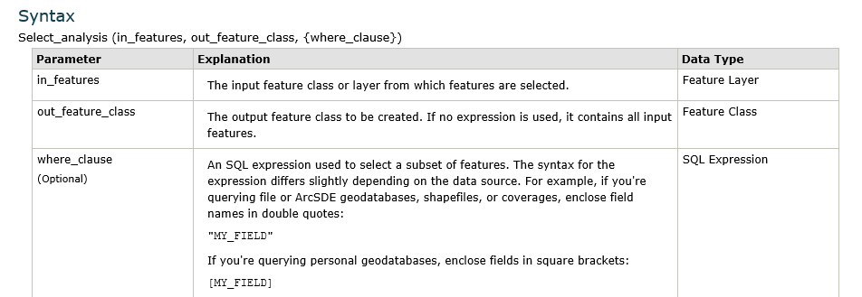

23. We pass these arguments into the function by putting them within the parentheses, but with each argument separated by a comma. (You may see arguments referred to as parameters instead, as seen above in the screenshot. In programming, the two can generally be used interchangeably). Understanding what arguments to pass and in what order is critical to using functions - and as a result, critical to moving forward with programming. Lucky for us, the majority of functions come with lots and lots of documentation so you can understand what you need to use and how the function expects to see it written - and this is very much the case for ArcPy. For example, the above documentation was found at http://help.arcgis.com/en/arcgisdesktop/10.0/help/index.html#//000800000005000000)..

24. The syntax also details the expected data type and, in some cases, formatting which will help to write your code. Also, as you can see in the where_clause parameter, this is actually optional. i.e. you can run your code without entering where, and there will be a default argument (i.e. select all) passed through. As you come across more and more functions, you’ll see many have a lot of optional arguments; what you need to always check is (a) whether there is a default and (b) if there is, does this default suit the processing you’re trying to do. In some cases, there is no default and Python will throw an error if you leave it out this parameter. We’ll try to find an example of this along our processing.

25. Fundamentally what you need to understand is a function does something to the arguments that you pass to it when it is called in your code. But what is also important to recognise at this stage is that there is a lot of documentation out there to help you. No one expects you to be able to just sit down a write code that works - it requires reading, researching and a lot of trying! So let’s write out our Select_analysis code ourselves.
26. Delete the code that appeared in the Python console - and then, rewrite it! Type in arcpy.Select_analysis and see what happens:

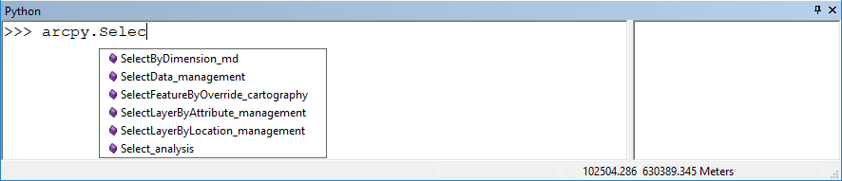

27. ArcPy begins to load up the different tools we might want to access, using the initial letters you begin to type. You can double click on the right function or finish typing it in to complete the function. Then enter the opening parenthesis:

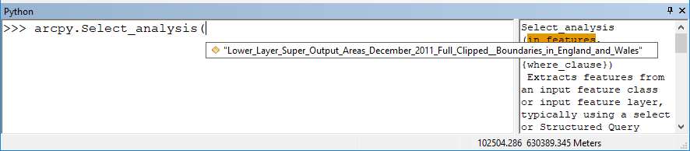

27. ArcPy automatically scans our Table of Contents to see what layer we are likely to perform our analysis on - and again we can double-click on the layer to enter it. Alternatively, the in_features argument would take a file path to our layer, entered as a string (as we see in our code above at Step 18). You can either write this path out yourself - or even better, drag and drop the required dataset from the Catalog window into the Python console, and ArcPy will fill this in for you! ArcPy also automatically populates the Help column part of the console with a version of the syntax documentation we saw earlier, including highlighting the current argument.

28. Once you’ve entered in our in_features argument, remember to type a comma to move onto the next argument, the out_feature_class. Here, ArcPy doesn’t have any suggestions - so we’ll have to enter this by ourselves. We need to state in one string, the file path, filename and file type that we wish to export our selected features to. Tip: as it’s a string, it all needs to read together within ONE set of “” (or ‘’) and without any spaces, including in the name that you set for the new LSOA file (which you should know already from the manual processing!). See if you can do this without looking back at our previous code!

Denoting and Exporting Different File Types

When you set the file name, you also have the option to set the file type you want the process to export your data to by writing this at the end of your file name. You should be familiar with file endings such as .shp, .tif, .txt, .csv, .geojson etc.. , but always check what file type you need for your next bit of processing or analysis.

If you export your data to a geodatabase, you should not set a file type and leave the data with just a file name. It will then be exported as a feature class to the geodatabase.

29. Enter in another comma to move onto our final argument: the selection query or where_clause. Finally we need to enter in our selection query - which is probably the most frustrating part, due to having to understand all the different syntax we may need to include. This time, you can cheat, and go straight to copying the code from Step 18.

30. As you do, have a look at the syntax of the selection query and think about how it differs to when we entered it within the Query Builder.

Escaping Quotes

Strings within strings are a nightmare. But they are also a key part of programming, especially within ArcPy and using selection queries. When writing our Select function, the selection query in the where_clause argument must be entered as a string – so it needs to be enveloped it in a set of “ ”. However, in the case of our query above, the next part of our query is a field, which itself in SQL requires “ ” to wrap around it. But as soon as we put another quotation mark next to the first, SQL automatically ends the string, and all of a sudden our field name is no longer a string, even if we add in the two afterwards. We actually end up with an empty string on one side of our field, and the remainder of the query is now also read as a string:

"EMPTY_STRING"lsoa11nm" LIKE 'Southampton %'"

This happens because some characters, such as the quotation mark, are considered “reserved” characters in the programming language and have a specific purpose such as starting and ending a string. Any time you use a reserved character as part of a string you have explicitly tell SQL or Python that this is not a reserved character. To prevent these escaping quotations, there are a few strategies you can employ. The easiest is to use a \ , which tells SQL or Python to ignore the special meaning of the following character. For example:

"\"lsoa11nm\" LIKE 'Southampton %'"

This works great as long as the following character is a reserved character (e.g ‘ \”) but sometimes you want to use \ in a string, most commonly when typing out the path to a file. In this case, you just have to escape the escape character: \\. Confused yet..?

When first starting out, it’s pretty useful to use the Query Builder and click and drag method to help figure out your “ ” if you find that you can’t quite get it right!
31. Once you’ve entered the query, make sure you close off your function arguments with the ending parenthesis ). And now we’re ready to execute our code. The code should now regenerate our Southampton LSOA shapefile - drag it into the Table of Contents (ToC) if it doesn’t add itself automatically.

A small difference in code – the preceding r and setting paths in Python

You may have noticed when dragging the code into the console that a small r appears before the path name. As you’ve just learnt above, Python will treat a backslash (\) as an escape character. As a result, when specifying a path, there three options to avoid your file from being misread:

1) Use forward slashes instead of a backslash;
2) Use two backslashes instead of one;
3) Use a string literal by placing the letter r before a string containing a backslash so it can be interpreted correctly.

When we drag our tools into the Python console, Arcmap uses the third option - and hence the appearance of the letter r before our file paths. For now, we’ll use this approach as we edit Arcmap-provided code. However, when writing our own code in Python, and as you’ll see tomorrow, we actually think using forward slashes is the simpler and more convenient option.

In the future, whatever approach you end up preferring, just (a) keep it consistent and (b) if you stick with single backslashes, don’t forget that r!

32. At this point we’ve managed to complete just the first step of our methodology. But hopefully you’ve learnt how we can use different parts of ArcMap to get from a click-through manual method to automating the step in just one or two lines of code. Now we’ll use this approach to complete Step 2!

Step Two: Joining our Population data to our Southampton LSOAs (Manual & Program)

33. The next step of our methodology is to join our 2016 and 2017 Mid-Year Estimate Population CSV datasets (that you would have cleaned yesterday) with our Southampton LSOA shapefile. This is a task - joining a CSV of data to a shapefile - you have likely done multiple times in your GIS modules - and will continue to do in the future as a GIS analyst. Being able to automate this would certainly be a great help in most of your future work.

34. As we have two CSVs of population data that we want to add to our Southampton LSOAs, we’re going to repeat our above approach of first manually adding the lsoa_pop_2016.csv file to our Southampton LSOA. Then using the Results of this tool, we can drag the code into our console and change it so we join the lsoa_pop_2017.csv file just using this code with a few modifications.

35. First we need find the right tool and once again we want to use the Search box for this. If we search for Join, we get quite a few hits - but there are two that look pretty useful (not the spatial join, but we’ll be using this later!).

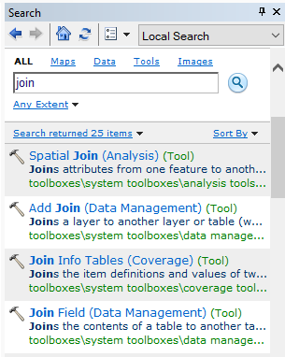

Looking at the Tool names it can be easy to think they do the same thing. But just like with the Select Toolbox, the tools within the Data Management Join Toolbox actually do different things. And we sometimes need to consider what our final output should be from our processing to workout which tool we need.

Tool Selection and GIS Processing Workflows

As you’ve probably found in the past, there are several ways to execute the same or similar GIS processing. You find one tool which does A and B, another that only does A, or another that does B. A bit like the case with our Select process previously - one tool would export out selection automatically, another would select our features but require some further processing to get this as a separate profile. Often it is just a simple case of trial and error - seeing if and what output you get and if this is what you wanted. But we should try to make informed decisions when choosing the tool we want to use. Let’s take our Join situation for example and have a look at the documentation associated with our two potential tools to see what they do:

Add Join | Join Field
http://pro.arcgis.com/en/pro-app/tool-reference/data-management/add-join.htm | http://pro.arcgis.com/en/pro-app/tool-reference/data-management/join-field.htm
Joins a layer to another layer or table based on a common field. Feature layers, table views, and raster layers with a raster attribute table are supported. The records in the Join Table are matched to the records in the input Layer Name. This join is temporary. | Joins the contents of a table to another table based on a common attribute field. The input table is updated to contain the fields from the join table. You can select which fields from the join table will be added to the input table.
AddJoin_management (in_layer_or_view, in_field, join_table, join_field, {join_type}) | JoinField_management (in_data, in_field, join_table, join_field, {fields})

We want to make our workflow as efficient as possible - the fewer steps of processing we need to do, the less likely we are to create a bug in our workflow and, of course, it’s just going to be quicker. But we also may want to prioritise other aspects of the processing above efficiency, for example, retaining a dataset and not overwriting it.

To demonstrate this, think about what you just read about the two tools. One of the tools above only creates a temporary join between the dataset and table, whilst the other is a permanent join. When a join is temporary, as soon as you remove the dataset from the Table of Contents or close down the Map Document you’re working on, the join no longer exists within that dataset.

In comparison, the other tool will create a permanent join, which means that the field (or fields) of the joined tables has been added to the original shapefile. This added data can be used within different projects and as well as within the same project at a later date but it does mean that the original file has been overwritten with this new data.

You can make a temporary join permanent by adding a second processing step. This involves copying the features over into a new dataset, either using the ‘Data’ → ‘Export Data’ option accessed through right-clicking on the layer in the Table of Contents or using the CopyFeatures tool.

For our processing, we want to end up with a shapefile with both the 2016 and 2017 population columns permanently added - and we’ll try to do this in as few steps as possible and as little edit of the code as needed.

The problem is there is no straightforward way of doing this without running into a few complications presented by ArcMap and its special ways of doing things. To demonstrate this, we’re providing two possible workflows - both have issues that need to be worked around in order to work. The first workflow is included in this workbook and we’d like you to complete this before going to lunch. The second is an extension activity and available from the front. Please come up and grab one if you would like.

Workflow 1: Using the Field Join function

Our first approach to joining our two population datasets to our Southampton LSOAs will be using the Field Join function. As you’ll have read in the documentation above, the function provides a permanent way of joining table data to spatial datasets. What’s great about it is that it allows you to specify which Fields you wish to join - so if you have a table with lots of fields but you only want one or two of them, you can make sure only the fields you want are included. See the Syntax below:

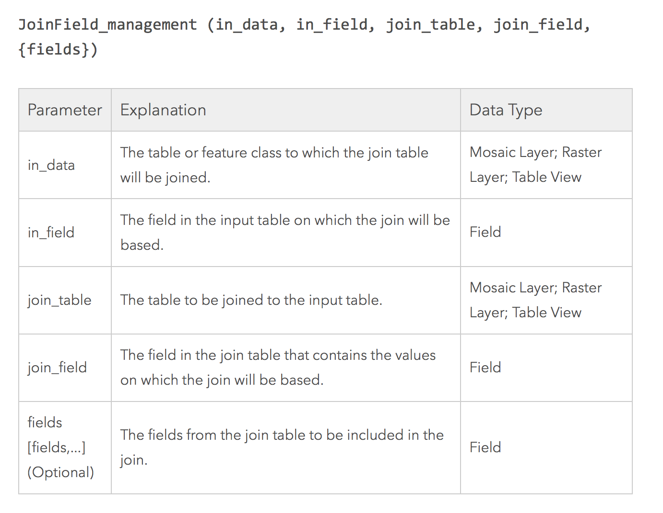

36. Before we get started with the JoinField_management tool, we want to account for the permanency of the Join. If we make a mistake or end up wanting to use the Southampton_LSOAs.shp in another project or for another set of processing, we may prefer that the population data isn’t already joined within the shapefile. So we’re going to create a copy of the Southampton_LSOAs.shp within the working_files folder and rename it to Southampton_LSOAs_Pop.shp. You can do this manually in Catalog (copy, paste and rename) - or try giving it a go using the Copy tool in the Python console, accessed by:

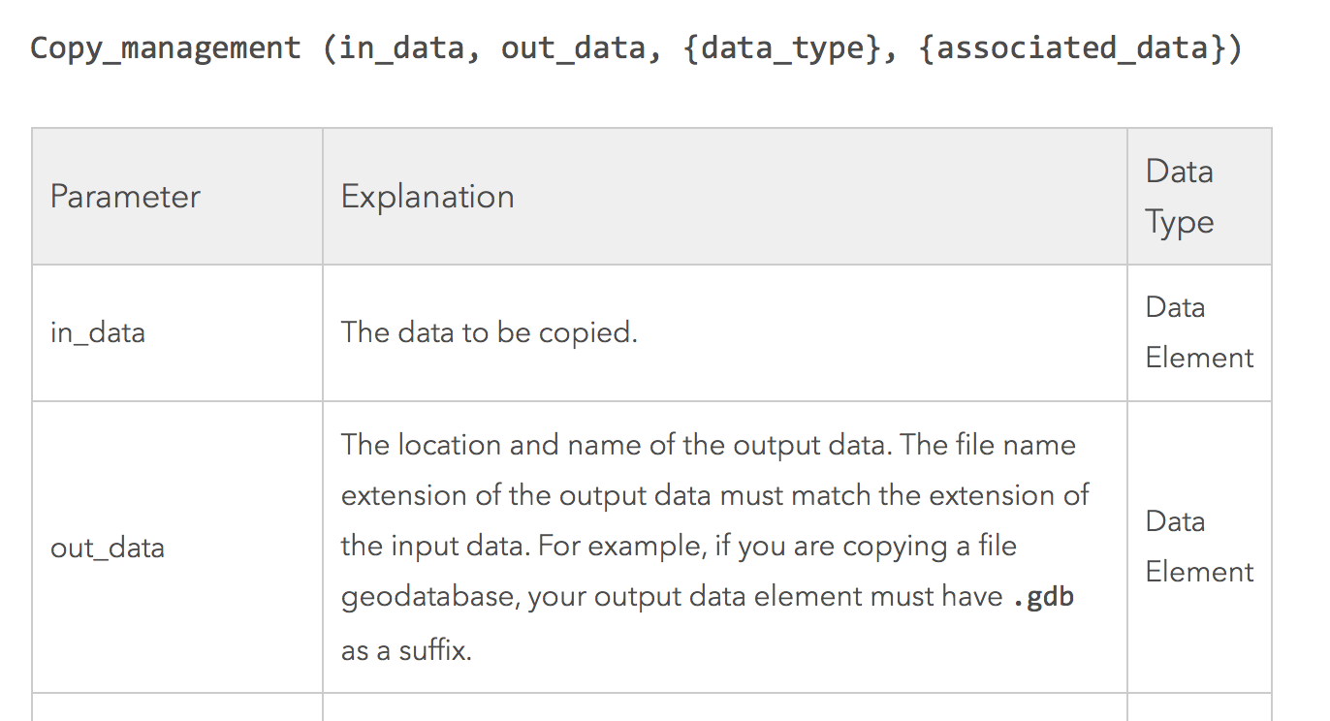

37. It’s a pretty simple function but there is an important piece of technical information to note. The Copy tool will only copy a Data Element, i.e. datasets (i.e. actual files within the Catalog) and not layers within the Table of Contents. As a result, it is best practice to use the full path of the dataset you wish to copy within the arguments and a full path for your output dataset as so:

>>> arcpy.Copy_management(r‘H:\Bootcamp\data\working_files\Southampton_LSOAs.shp’, r‘H:\Bootcamp\data\working_files\Southampton_LSOAs_Pop.shp’)

AND NOT:

>>> arcpy.Copy_management(‘Southampton_LSOAs’, r‘H:\Bootcamp\data\working_files\Southampton_LSOAs_Pop.shp’)

For our purpose, we don’t need to worry about the other optional arguments. But as always, be aware that they’re there and what they can do - it might end up being a useful addition for future work, such as being able to constrain the dataset that is copied by file type!

The easiest way to add the whole path is to drag the Southampton_LSOAs.shp over from the Catalog into the console. Don’t forget to end your function with a )!

38. Once you’ve copied your data, remove the original Southampton_LSOAs layer from the Table of Contents. Make sure you add the Southampton_LSOAs_Pop.shp as a layer if it hasn’t added itself already.

39. Now we’re ready to join our population data to our Southampton_LSOAs_Pop.shp.

40. We’re first going to complete the join manually so we can drag across our processing into the Python console. Open up the Search window and re-find the Join Field tool. Open the tool and enter in our required datasets. Remember, you always join a table to the spatial data, so your Southampton_LSOAs_Pop will be the Input Table.

41. You should also be very familiar with joining LSOA-specific data, so you should know which Join Field you will use. If you’re unsure, you’ll need to look back at both the Southampton_LSOAs_Pop.shp and the lsoa_pop_2016.csv data to find a common Field.

40. You can then add the lsoa_pop_2016.csv table into the tool using the Folder button and select the appropriate Output Join Field.

41. As we don’t want to double-up on data we already have (e.g. the LSOA name and LSOA code), we only want to join the population data column to our dataset. Use the Join Fields option to select only the “POP_2016” column.

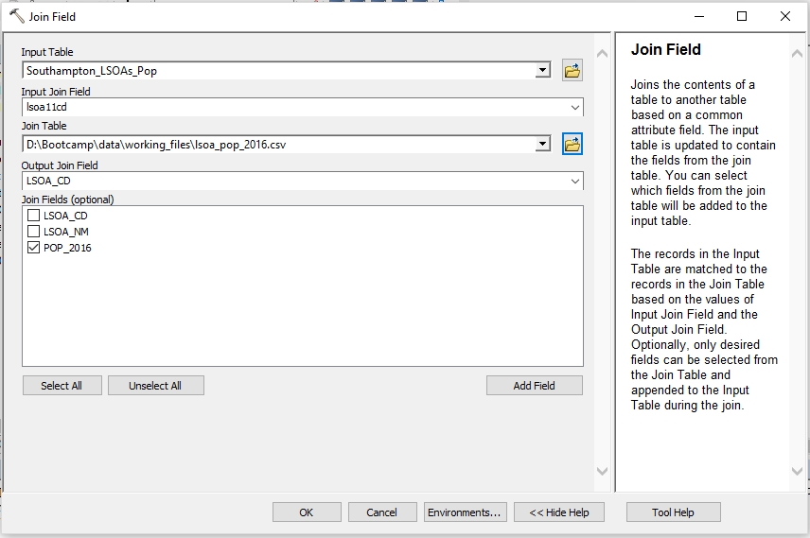

42. Run the tool.

43. Yikes, we’ve hit an error. Not cool Geography Programming Bootcamp - you should have sussed this all out before. Well, we did. But sometimes the best way to learn things is to experience it yourself - and as stated earlier on, none of these joining processes were going to be easy. Have a look at the Error message in the Results window and see where we’ve gone wrong - or if we have a bug.

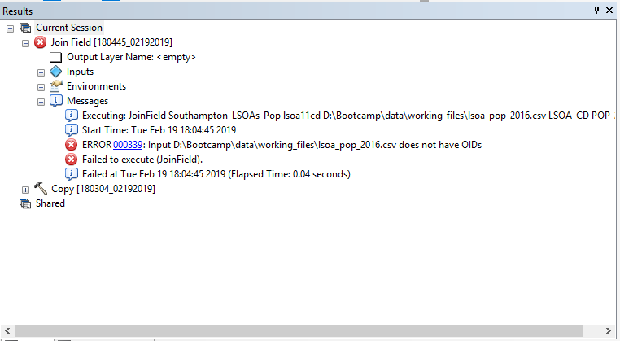

44. Well I don’t know about you, but I’m not entirely sure what OIDs mean - and if I did, how to create them. Not off the top of my head anyway. Luckily arcmap wants to help us again and we can click on the blue error number to find out what the Error means.

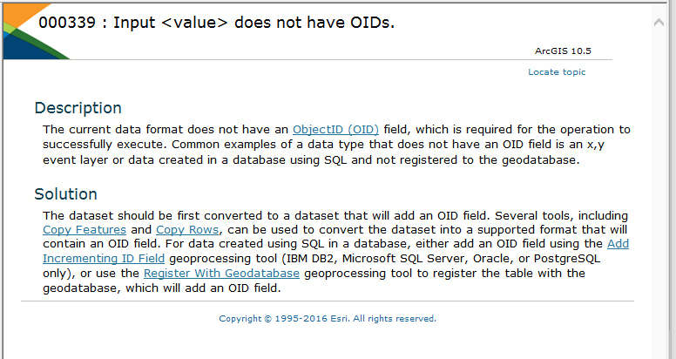

45. Reading through the Description and Solution, it sounds like ArcMap is not reading my CSV because it does not have an ObjectID field i.e. it’s capable of not reading and indexing each individual row in my CSV without a field stating Object 1, Object 2, etc. So I need to give it one - and the easiest solution to that seems to be using one of the other Copy tools, either Copy Features or Copy Rows.

46. Again, I need to do some investigation and find out what each of the tools do and what the differences are to determine which tool to use. Click through the Help documentation to find out more about the different tools:

Copy Features | Copy Rows
http://pro.arcgis.com/en/pro-app/tool-reference/data-management/copy-features.htm | http://pro.arcgis.com/en/pro-app/tool-reference/data-management/copy-rows.htm
Copies features from the input feature class or layer to a new feature class. If the input is a layer which has a selection, only the selected features will be copied. If the input is a geodatabase feature class or shapefile, all features will be copied. | Copies the rows of a table, table view, feature class, feature layer, or raster with attribute table to a new geodatabase, .csv, .txt, or .dbf table. If the table or feature layer has a selection, only the selected rows are copied to the output table.
CopyFeatures_management (in_features, out_feature_class, {config_keyword}, {spatial_grid_1}, {spatial_grid_2}, {spatial_grid_3}) | CopyRows_management (in_rows, out_table, {config_keyword})

47. In our case, the two copy functions would produce a similar output. Both functions can read in Tables and then write to a new Table. It is important to note though that the CopyFeatures_management function will only copy the data over into a new feature class within a Geodatabase and not a seperate table. In comparison, the CopyRows_management function can copy data into new tables. It is however is built only for copying tables, as shown by the documentation. If we were trying to copy spatial data, we wouldn’t be able to use it as it would only copy the Attribute Table and not the actual spatial data e.g. the points, lines or polygons.

48. Let’s go ahead and use the CopyRows_management to export our lsoa population data CSVs into our bootcamp geodatabase as a table - this will give them an OID and solve our current Join issues.

49. Open the Copy Rows tool from Search window. Select the lsoa_pop_2016.csv as our input rows. As its our default GDB, ArcPy automatically fills our export out with the Bootcamp.gdb and with an automatic name for our table. We want to keep the same name as our csv for our layer so remove the _CopyRows from the name. Run the tool.

50. Let’s see if our export worked and check that we now have a new feature class within our Bootcamp.gdb.

51. We now need to repeat the process for the 2017 data but it’d be great to find an efficient way to do this without all the clicking through. We can actually use our new found ArcPy approach to do this.

52. Drag the CopyRows process from the Results window to the Python console and change both years from 2016 to 2017 (so it reads in the 2017 data and writes it out as 2017 data. And that’s it. Run the code and the table will be exported. Ultimately, the code is very simple - and similar to the Copy tool we used above, it just has an extra argument at the end but even this we can ignore for now.

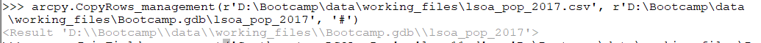

53. We can check again that the data exported correctly, checking our Bootcamp.gdb and if you want, opening the tables up.

54. Right, now we can get back to the Joining of our toolset. The thing is, we’ve already gone through the process of setting up our Join Field tool, and it seems like wasted effort to do it again - when all we need to do is change the Join Table. So it makes sense that instead of using the click process, we go straight to editing our code from the tool that didn’t work!

55. As you’ve done before, drag the failed Join Field tool from the Results window into the Python console to display the code that would have run our failed process. Note the Join Field tool is denoted as JoinField_management when used as a function.

56. Before we can re-run the code, we need to replace the Join Table path to our original lsoa_pop_2016.csv to the path of the new lsoa_pop_2016 table within our geodatabase. To do so is actually quite simple. We can copy the output path from the above CopyRows_management code and paste this in the place of the Input path in our JoinField_management function. But as we want to join the 2016 data first, we need to edit our path to make sure it goes to the 2016 dataset and not the 2017. You can double check this by looking at the Field we are joining (i.e. POP_2016). Make sure when copying the path over that you include the preceding r to ensure that the path is read as a string.

57. Once you’ve edited your code, run the function.

58. You can check to see that the join has worked by opening up your Southampton_LSOAs_Pop shapefile and checking that the POP_2016 column has been added.

59. If it’s worked, it’s time to move on to joining the 2017 dataset. And all it takes is a couple of tricks and edits. Within the Python Console, press the Up Arrow once. What you will see is the code that you just entered and ran appears in the console. It’s a really nice shortcut to access code and commands you may have just entered. Here we only need to press the arrow once as you did, but you can keep pressing it to scroll through your history to get to the code you want to see or edit.

60. Now we have our JoinField_management code in front of us, we just need to make two edits to ensure that it (a) runs on the new lsoa_pop_2017 table and (b) runs successfully by adding the POP_2017 column. You should probably be able to guess what these two edits are! Go ahead, edit the code and then run it to join our dataset.

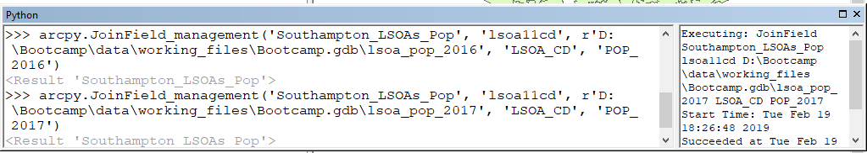

61. Great - we can now check that we have both population data columns added.

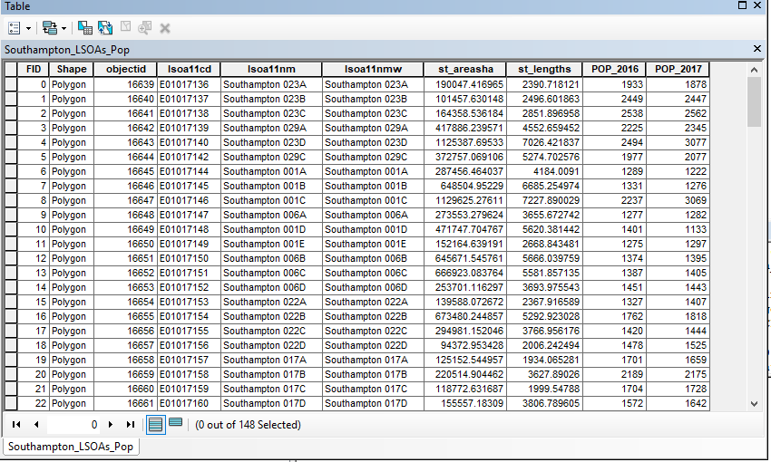

62. The final thing to do is to re-project our final shapefile from its original coordinate reference system (CRS) of British National Grid to WGS84 (GCS_WGS_1984). This is because our crime data, as you would know from looking at it this morning and taking note of the field names, is provided with coordinates rather than northing and eastings. As a result, this data will be rendered in WGS84. To prevent any projection issues, we’ll solve this now by using the Project tool (we’ll learn how to code this up this tomorrow). We need to enter our Southampton_LSOAs_Pop.shp as our input dataset, set the output CRS to GCS_WGS_1984 (you can search for this by typing wgs in the search box and opening Geographic Coordinate Systems → World → WGS 1984). Then call our output dataset, Southampton_LSOAs_Pop_WGS84.shp. If you have any issues with projecting your shapefile, let us know - but this is all the written instructions you’ll get to do this!

63. Now we’ve reprojected our Southampton LSOA Pop shapefile to WGS84, we want to set up the rest of our project accordingly. We need to set the mxd project default CRS settings to WGS84 as well. If you were unaware, the project inherits the CRS of the first dataset added into the canvas, in this case BNG.

64. Make sure to remove any layers except the Southampton LSOA Pop WGS84 shapefile from your Table of Contents.

65. In the Table of Contents, click on the Layers heading and select Properties. Navigate to the Coordinate System and find our WGS 1984 CRS again. (You might want to right-click on it and select ‘Add to Favourites’). Click Apply and the O.K. If you’ve left anything on the map with a non-WGS 1984 CRS, ArcMap will let you know!

66. Make sure to save your .mxd! Hopefully you’ve been saving this throughout the day.

If you’ve finished before the end of the day, come and grab the Extension Activity. In the end, we create the same output but using a different set of processing - and coming across a different set of problems.

Reflecting on what we’ve covered today:

The aim for today was to get you started thinking about how to plan a Research Project, how to manage your data and then getting you familiar with using the Python console in ArcMap as well as basic Python syntax. It is important to get these foundations and fundamentals right for the rest of our project here (and hopefully your work in the future). Have a look at our list below, and if there’s anything you’re still unsure of, make a note to follow this up with either your own research or come and ask us at the end of today.

- Research planning
- File management
- Data naming conventions
- Designing appropriate research methodology
- Creating GIS workflows
- Using the Python terminal within ArcMap
- Using the Results window with the Python terminal within ArcMap
- SQL Queries and Syntax
- ArcPy Geoprocessing functions and their parameters
- Denoting different files types in code
- Understanding strings and escaping quotes
- Writing out correct file paths
- Choosing the appropriate geoprocessing tool/function

Updated Files and Folder Structure: End of Day One